Counting unordered items

Task 1 . Items that are out-of-order

The purpose of the flowchart is to count the number of pairs of items that are not in the right order. The order that the items should be in is the lowest value to the highest.

Analyse the flowchart and then answer the questions that follow.

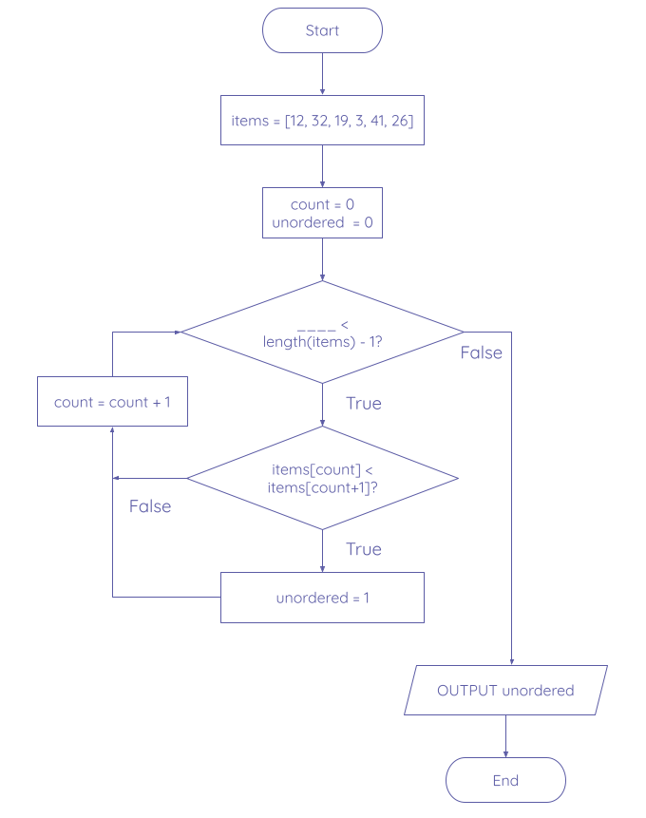

What is the missing part of the first condition?

|  |
| --- |

Why is the first condition based on length(items) - 1?

|  |
| --- |

There are two errors in the flowchart. **Fix** the errors by listing the correct statements below. **State** the type of error it is and **explain** your reasoning for each correction.

| 1.  2. |
| --- |

Explorer task .

Using the below code from the starter activity, create a flowchart for this algorithm that uses more meaningful identifiers than the existing ones.

| 1  2  3  4  5  6  7  8 | def mystery(my_list, thing):  i = -1  num = 0  while num < len(my_list):  if my_list[num] == thing:  i = num  num = num + 1  return i |
| --- | --- |

Flowchart:

|  |
| --- |